COMMON LABORATORY TECHNIQUES

Reading a Meniscus

In all volumetric glassware (pipet, buret, volumetric flasks, graduated cylinder, etc.), it is necessary to read the level of a liquid. A liquid
in a small-diameter container will form a meniscus or curve at the surface of the liquid. Usually this meniscus curves downward to a minimum at the center. To read the level of the liquid properly, the eye should be at the same level as the bottom of the meniscus. Sometimes a white card or a white card with a black mark on it will help a person to see the meniscus clearly. For volumetric flasks and transfer pipets, the volume of the glassware is exact when the bottom of the meniscus is even with the etched line. In a graduated cylinder or a buret, the volume is read from the graduations etched on the glass. To read the volume correctly, visualize the distance between the tenths of milliliter marks as divided into ten equal amounts.
The volume is then found by reading the number of tenths of milliliters and estimating hundredths of
milliliters.

100

90

Graduated
Cylinder

91.7

46

47

Buret

46.3

Titration

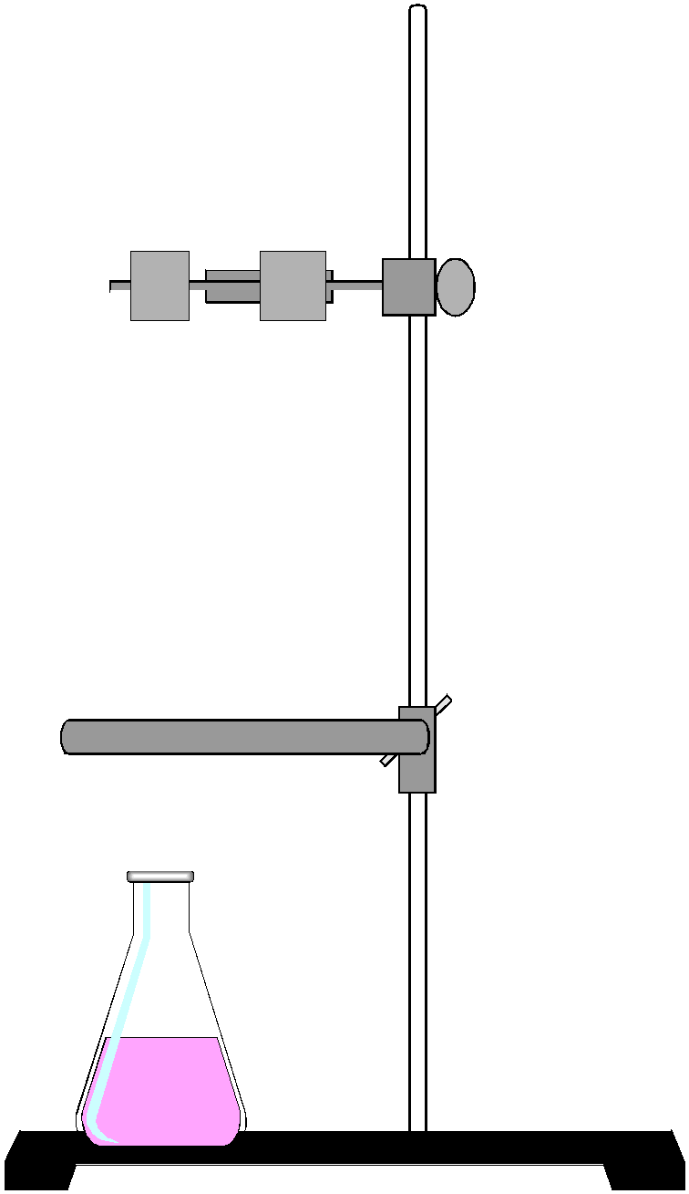
The titration procedure is accomplished by adding small amounts of one reactant to a beaker or flask containing the other until the reaction is completed. In an acid-base reaction, the reaction is complete when the amount of acid equals the amount of base. The experimenter is aware of this condition by the change in pH that occurs. The change in pH is indicated by a color change of an indicator or by a pH meter. In other types of reactions, the completion of the reaction is usually also indicated by a color change. Titrations are often accomplished using a buret. A small amount (5 - 10 ml) of the solution is used to rinse a clean buret. The rinse solution is discarded. The buret is filled to just below the zero mark. The liquid level is read and recorded as the initial volume. A buret has zero at the top as shown in the picture. Small amounts of the solution are allowed to flow out of the buret into the flask by turning the stopcock. Often localized color changes will be evident for a short period of time. Mixing the solution by swirling the flask will usually cause the color to return to the original color. As the color lasts longer, the next addition of solution needs to be smaller. Close to the endpoint (reaction completion), the additions are one drop at a time. When the endpoint is reached, the liquid level is read and recorded as the final volume. The volume added is the final volume minus initial volume.

VOCABULARY
accomplish - wykonać  balance – waga  beaker – zlewka  buret/burette – biureta  burner - palnik  clay triangle – trójkąt do tygli (clay – glina)  crucible – tygiel  desiccator – eksykator  discard – pozbyć się  dispense - rozdzielać  dropper – wkraplacz / zakraplacz, kroplomierz  etched – wytrawiony (kwasem)  filter paper - sączek  flask – kolba (flat-bottom – płaskodenna;  funnel – lejek (separatory funnel – rozdzielacz); przelewać lejkiem  indicator - wskaźnik  laboratory apparatus – aparatura laboratoryjna  round-bottom – okrągłodenna; three-neck – trójszyjna;  volumetric – miarowa; Erienmeyer - stożkowa) | fume hood – wyciąg (dygestorium)  graduated cylinder – cylinder miarowy  graduation – tu: podziałka  laboratory equipment – sprzęt laboratoryjny  mortar – moździerz  noxious – trujący  potassium permanganate – nadmanganian potasu  pH-meter – pH metr  pipet/pipette – pipeta, odmierzać pipetą  rinse - przepłukać  sample - próbka  species – gatunek / -ki  stirrer – mieszadło (magnetic stirrer – mieszadło magnetyczne)  stopcock – zawór odcinający, korek  titrate - miareczkować  titration - miareczkowanie  tongs – szczypce  tube – probówka  tube holder – łapa do probówek  watch glass – szkiełko zegarkowe

1) dropper |  | A) equipment used to ventilate noxious or harmful gases
2) beaker |  | B) apparatus used to dispense small quantities of liquids
3) pipet |  | C) reaction container usually made of glass, used to hold liquid or solid samples
4) funnel |  | D) a solution of known concentration which is added (titrated) to another solution to determine the concentration of a second chemical species
5) fume hood |  | E) apparatus used for addition of liquids drop by drop
6) titrant |  | F) apparatus used for funneling liquids from one container to another or for filtering when equipped with filter paper

Zad. 1 Match the words with their definitions
Zad. 2 Translate the sentences below into English:
- Przegapiłem punkt końcowy. Znów dodałem za dużo roztworu nadmanganianu potasu.
...............................................................................................................................................................
- Gdyby Jack użył mieszadła magnetycznego zamiast łyżeczki, nie zbiłby zlewki.
..............................................................................................................................................................
- Miareczkowałem wczoraj przez 3 godziny. Ból pleców mnie zabija!
..............................................................................................................................................................
- Zamierzam przepłukać kolbę okrągłodenną i odmierzyć pipetą 2 mililitry wskaźnika.
.............................................................................................................................................................

Zad. 3 Choose the correct answer
a) You need to shake / swirl / swing the flask to check if the titrated solution returns to its original color.
b) If you want to read the level of liquid in burette properly, keep your eye on / above / below the level of meniscus.
c) In acid-base reaction, you achieve the endpoint when the amount of acid is bigger than / equals / is smaller than the amount of base.
d) A buret has zero at the top / at the bottom / anywhere you want.
e) In titration, as the color of analyzed solution lasts longer, but vanishes, you need to add smaller / bigger / no more portion of titrant.

