Periodic table

Although the periodic law is generally accepted and there is general agreement that the elements should be arranged in cycles, there is still much argument as to how the elements should be displayed to represent these cycles. Figure 1 shows one of the most commonly used forms of the periodic table. The basic features of the arrangement are horizontal rows called periods and vertical columns called groups. The horizontal periods represent the cycles that have to be traversed to get back to similar properties; the vertical groups collect together the elements that have similar properties. As shown in Fig. 1 across the top, the groups are numbered by Roman numerals. Group I contains hydrogen and the elements lithium, sodium, potassium, rubidium, cesium and francium. Group II contains beryllium, magnesium, calcium, strontium, barium and radium. At the extreme right is group 0, comprising helium, neon, argon, krypton, xenon and radon. Between groups II and III, which are sometimes called main groups, there are 10 short groups, marked “transition elements”, which are called subgroups. In some designations these columns are labeled III B, IV B, V B, VI B, VII B, VIII B(covering three columns), I A and II A, in other designations, the A and B are interchanged.
Since chemists themselves cannot agree on the A and B designation and frequently get them mixed up, it is better to omit these designations. They are relics of the original Mendeleyev’s table, which was squashed together so that for the long periods two elements were made to appear in the same box, instead of referring to the name of the head element.
Along the left side of the periodic table in Fig. 1. the period designations are given in Arabic numerals. Period I, the top horizontal contains only two elements: hydrogen and helium. Period II consists of 8 elements: lithium, beryllium, boron, carbon, nitrogen, oxygen, fluorine and neon. Period III, the third horizontal row, also has 8 elements: sodium, magnesium, aluminium, silicon, phosphorus, sulfur, chlorine and argon.

GLOSSARY:
Appear – występować
Arrange – ułożyć
Arrangement – układ
Basic – podstawowy
Commonly – powszechnie
Comprise – składać się, zawierać
Cover – obejmować
Designation – oznaczenie, nazewnictwo
Elements – pierwiastki
Extreme – skrajny
Feature – cecha
Horizontal – poziomy
Interchange – zamiana, wymieniać
Label – oznaczać opisać
Main – główny
Omit – pomijać
Properties – własności
Refer to – odnosić się do
Row – rząd
Similar – podobny
Successive – kolejny
Transition – przejście
Vertical – pionowy

ELEMENTS – Give their symbols and Polish names.
hydrogen
lithium
sodium
potassium
rubidium
cesium
francium
beryllium
magnesium
calcium
strontium
barium
radium
helium
neon
argon
krypton
xenon
radon
boron
carbon
nitrogen
oxygen
fluorine
aluminium
silicon
phosphorus
sulfur
chlorine

Figure 1

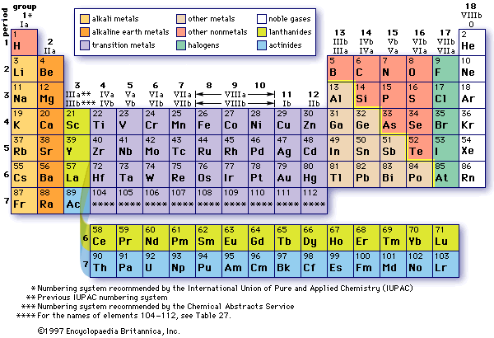
EXERCISE 1.
Match each symbol with its name.

- argon
- magnesium
- neon
- strontium
- phosphorus
- xenon
- beryllium
- nitrogen
- silicon
- chlorine
- Ne
- Xe
- Be
- Cl
- Si
- N
- Ar
- P
- Sr
- Mg

EXERCISE 2.
Complete the sentences.
- Group I contains: __________,__________, sodium,__________,___________,___________, and francium.
- Group II contains: beryllium ,___________,___________,_________,barium and ____________
- Period 1 contains ______ elements: _________________________
- Period 2 consists of ______ elements: _____________________________________
- Period 3 has_____ elements: ____________________________________________

EXERCISE 3.
Complete the sentences with the following words:
GROUPS, SUBGROUPS, PERIOD, periods
1) The basic features of the arrangement are horizontal rows called _______ and vertical columns called __________
2) _________ are numbered by Roman numerals.
3) _______ designations are given in Arabic numerals.
4) Between groups II and III there are ____________

